**Tea and Code**

### 1. Introduction

● I think tea ceremony is an art, and coding is also an art. The code represents busy, and the tea ceremony represents leisure, just like life.

This website is mainly a personal blog website. I can publish the new technology I have learned and the understanding of technology. And I can post relevant industry articles and trends. And I can discuss each other with people who read my blog and learn from each other.

● This app can provide me with a platform to record my learning journey and may provide ideas and solutions for others to solve a problem. In the same way, I can discuss a technical issue with people who read my blog.

### 2. Expected List of Features

#### A brief list website to support

log in (support Google and Twitter)

Comment

Rss subscription

Email feedback

Search

Share

…

#### Brief justifications for including these features.

A website that supports login is a very important feature. After logging in, people can leave their comments (or enter their emails and nicknames to comment). Comments allow me to interact with my readers. This is an important feature. And I hope to support Google and Twitter logins, because this will reduce the time cost people spend on registration, and it will be easier to comment, rather than paying attention to registration.

In addition, I think RSS subscriptions are also a very important feature of blog sites, especially in the era of information redundancy, rss subscriptions are very suitable for fragmented reading, when you open rss software, like: feedly, you can see All the websites and news you care about improve our reading experience

As for the email feedback function, I can interact with my readers' fingertips, website issues or technical issues, and even some other things, not just the subject of an article.

The search function is also the same, I will provide labels and categories to help readers find a topic, but this will not be conducive to the reader's query, so the search function allows visitors to query keywords to find special content.

Sharing allows visitors to share articles that they find meaningful to other social media, not only to share articles, but also to increase the exposure of the site.

### 3. Market Survey

#### five web sites that might have similar ideas

1. http://www.ruanyifeng.com/home.html

2. https://blog.jimmylv.info/

3. https://patdash.planetchili.net/

4. https://alistapart.com/

5. https://www.dailyblogtips.com/

#### Briefly compare the features of these applications with your application idea.

Chart 1.0 is a table created by my simple comparison of the functions of the above websites.

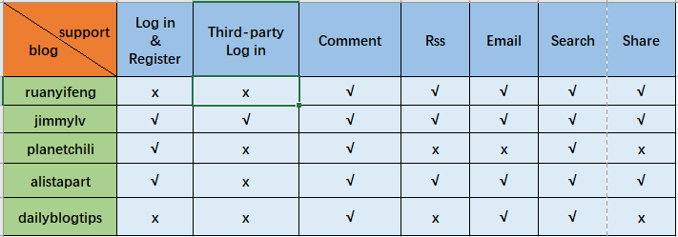

Chart 1.0

### 4. References

#### Give references to any material / websites / books etc. relevant to my application idea

Websites：

[Daily Blog Tips](http://www.dailyblogtips.com/)

[Successful-Blog](http://www.successful-blog.com/)

Books：

《The Elements of User Experience: User-Centered Design for the Web and Beyond，Second Edition》 Jesse James Garrett ,2011.7

《Simple and Usable Web,Mobile,and Interaction Design》[English] Giles Colborne 2011.1

#### the links to the websites relevant to my idea, that I listed in the section above.

<http://www.ruanyifeng.com/home.html>

<https://blog.jimmylv.info/>

<https://patdash.planetchili.net/>

<https://alistapart.com/>

<https://www.dailyblogtips.com/>